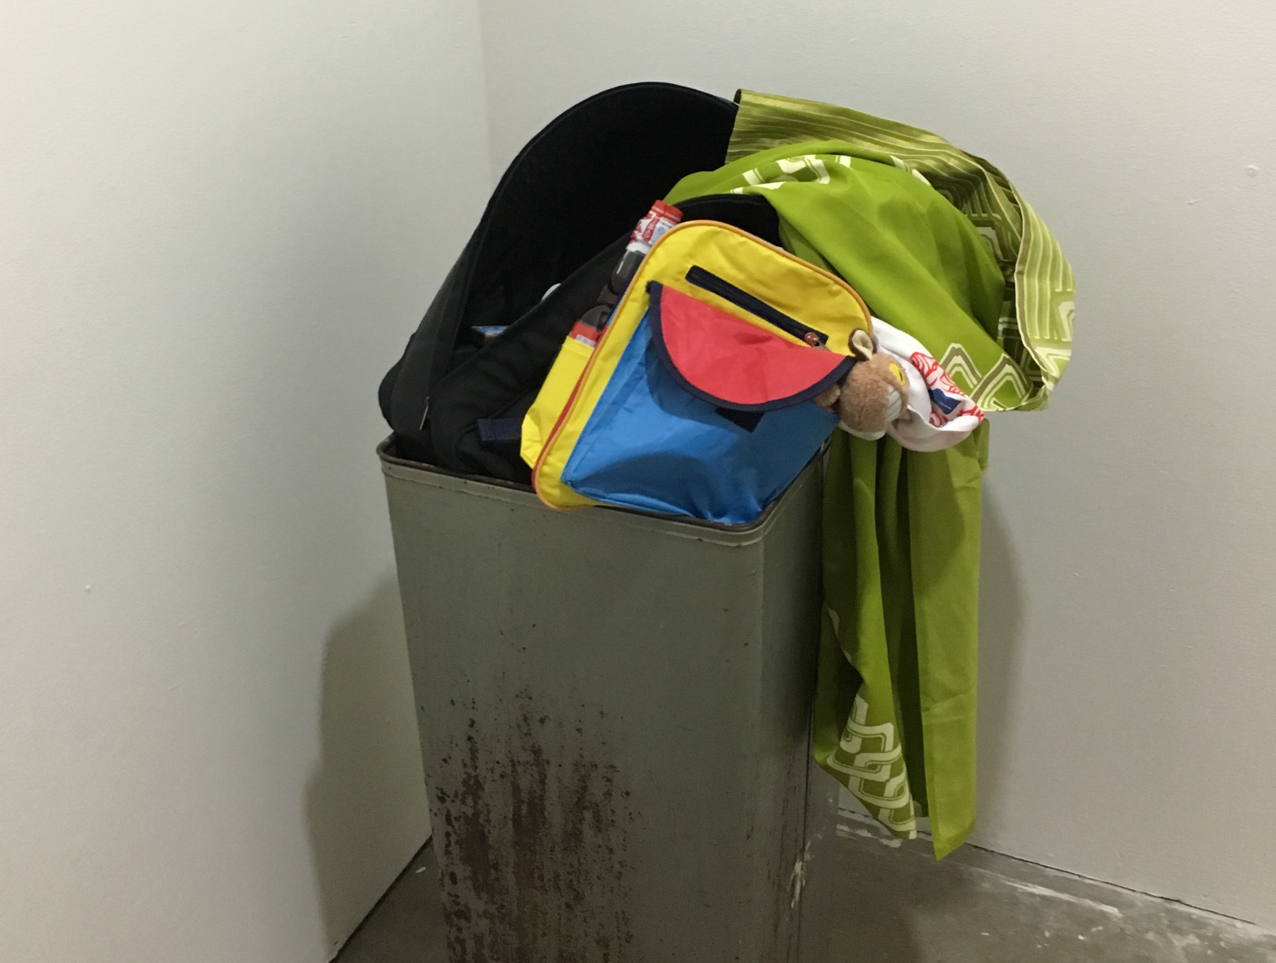

Trash Can, Backpack, Kimono… etc.

14” x 14”

Received: TBD

Time Spent: 14 hours

Initial Reaction: 4/10

Cost of Materials: $130.22

This work was received somewhat badly in crit and received an overall grade of TBD upon evaluation. The total hours/money spent on labor and cost of materials was above average.

Add To Cart: **$30.8- $340.22**  [See Pricing Sheet](Pricing%20Sheet.docx)

Paper & Ink

11” x 8.5”

Received: 3.3

Time Spent: 5 hours

Initial Reaction: 7/10

Cost of Materials: $18

This work was received well in crit and received an overall grade of 3.3 upon evaluation. The total hours/money spent on labor and cost of materials was below average.

Add To Cart: **$11.10**  [See Pricing Sheet](Pricing%20Sheet.docx)



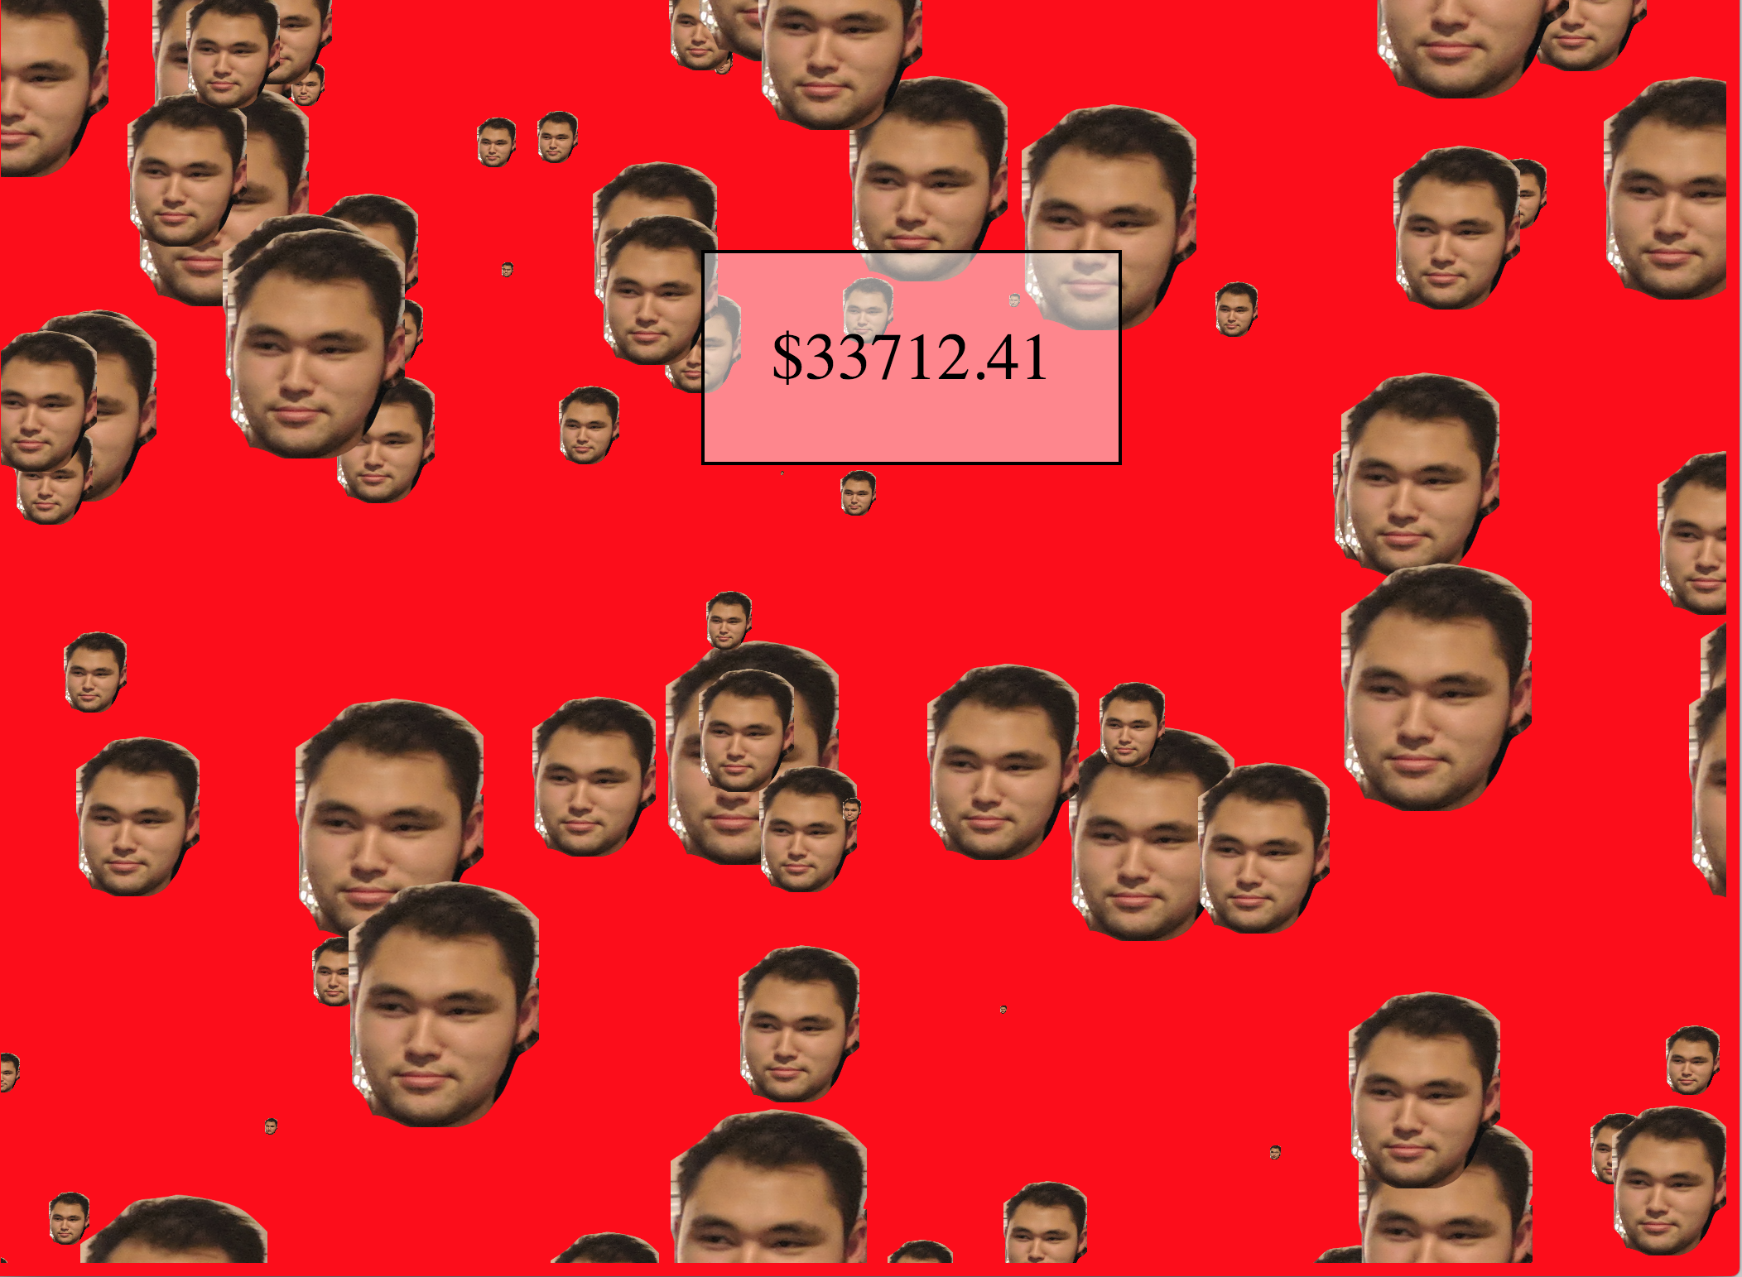

Life Source, Creativity, Labor, Money…

? x ?

Received: TBD

Time Spent: TBD

Initial Reaction: TBD

Cost of Materials: TBD

This work was received TBD in crit and received an overall grade of TBD upon evaluation. The total hours/money spent in labor and cost of materials was vastly above average.

Add To Cart: **$33,712 +**  [See Pricing Sheet](Pricing%20Sheet.docx)

Website

? x ?

Received: TBD

Time Spent: 16 hours

Initial Reaction: TBD

Cost of Materials: $80

This work was received TBD in crit and received an overall grade of TBD upon evaluation. The total hours spent on labor was above average and the total cost of materials was average.

Add To Cart: **$35.52-$3280** [See Pricing Sheet](Pricing%20Sheet.docx)

